High Level Design

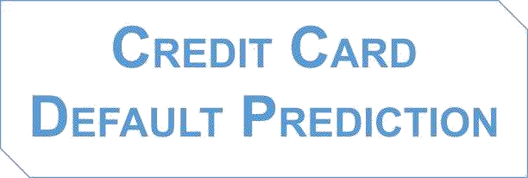

**Submitted by:**

Suchindra Kumar

# Introduction

A credit card default occurs when a cardholder fails to make the minimum required payments on their credit card account for an extended period of time. This can happen for a variety of reasons, such as a loss of income or an unexpected expense. When a credit card account goes into default, the card issuer may take legal action to collect the unpaid balance, and the cardholder's credit score may be negatively affected. Additionally, the card issuer may also charge additional fees or penalties. To avoid default, it is important for cardholders to make timely payments and to contact their issuer if they are having difficulty making payments.

# Problem Statement

Banking or Financial Institutes plays a significant role in providing financial service. To maintain the integrity, bank must be careful when investing in customers to avoid financial loss. Before giving credit to borrowers, the bank must come to about the potential of customers. Therefore, the goal is to predict the probability of credit default based on credit card owner's characteristics and payment history.

# Dataset Overview

**ID:** ID of each client

**LIMIT_BAL:** Amount of given credit in NT dollars (includes individual and family/supplementary = credit)

**SEX:** Gender (1=male, 2=female)

**EDUCATION:** (1=graduate school, 2=university, 3=high school, 4=others, 5=unknown, 6=unknown)

**MARRIAGE:** Marital status (1=married, 2=single, 3=others)

**AGE:** Age in Years

**PAY_0:** Repayment status in September 2005 (-1=pay duly, 1=payment delay for one month, 2=payment delay for two months … 8=payment delay for eight months, 9=payment delay for nine months and above)

**PAY_2:** Repayment status in August 2005 (scale same as above)

**PAY_3:** Repayment status in July 2005 (scale same as above)

**PAY_4:** Repayment status in June 2005 (scale same as above)

**PAY_5:** Repayment status in May 2005 (scale same as above)

**PAY_6:** Repayment status in April 2005 (scale same as above)

**BILL_AMT1:** Amount of bill statement in September 2005 (NT dollar)

**BILL_AMT2:** Amount of bill statement in August 2005 (NT dollar)

**BILL_AMT3:** Amount of bill statement in July 2005 (NT dollar)

**BILL_AMT4:** Amount of bill statement in June 2005 (NT dollar) **BILL_AMT5:** Amount of bill statement in May 2005 (NT dollar) **BILL_AMT6:** Amount of bill statement in April 2005 (NT dollar)

**PAY_AMT1:** Amount of previous payment in September 2005 (NT dollar)

**PAY_AMT2:** Amount of previous payment in August 2005 (NT dollar)

**PAY_AMT3:** Amount of previous payment in July 2005 (NT dollar

**PAY_AMT4:** Amount of previous payment in June 2005 (NT dollar) **PAY_AMT5:** Amount of previous payment in May 2005 (NT dollar) **PAY_AMT6:** Amount of previous payment in April 2005 (NT dollar)

**Default payment next month:** Default payment (1=Yes, 0=No)

# Tools Used

Python programming language and frameworks such as NumPy, Pandas, Scikit-Learn, Matplotlib and Seaborn are used to build the whole model.

# Design Flow

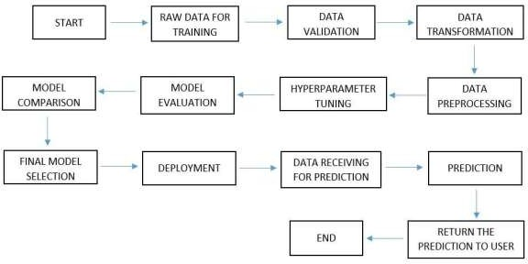

* Conclusion

The project is designed in the flask. Hence it is accessible to everyone. The above design process will help banks and loan lenders predict whether customers will default the credit card payment or not, so the bank or respective departments can take necessary action, based on the model's predictions. The Design is made to be user-friendly so that the user will not need much knowledge of any tools but will just need the information for results.